
Age of swimmers as of 23:59 19th October 2025
L3 County Qualifier

18th & 19th October
2025

Licence No.
-

TBC

QUALIFYING TIMES

Minimum Age - 9 years
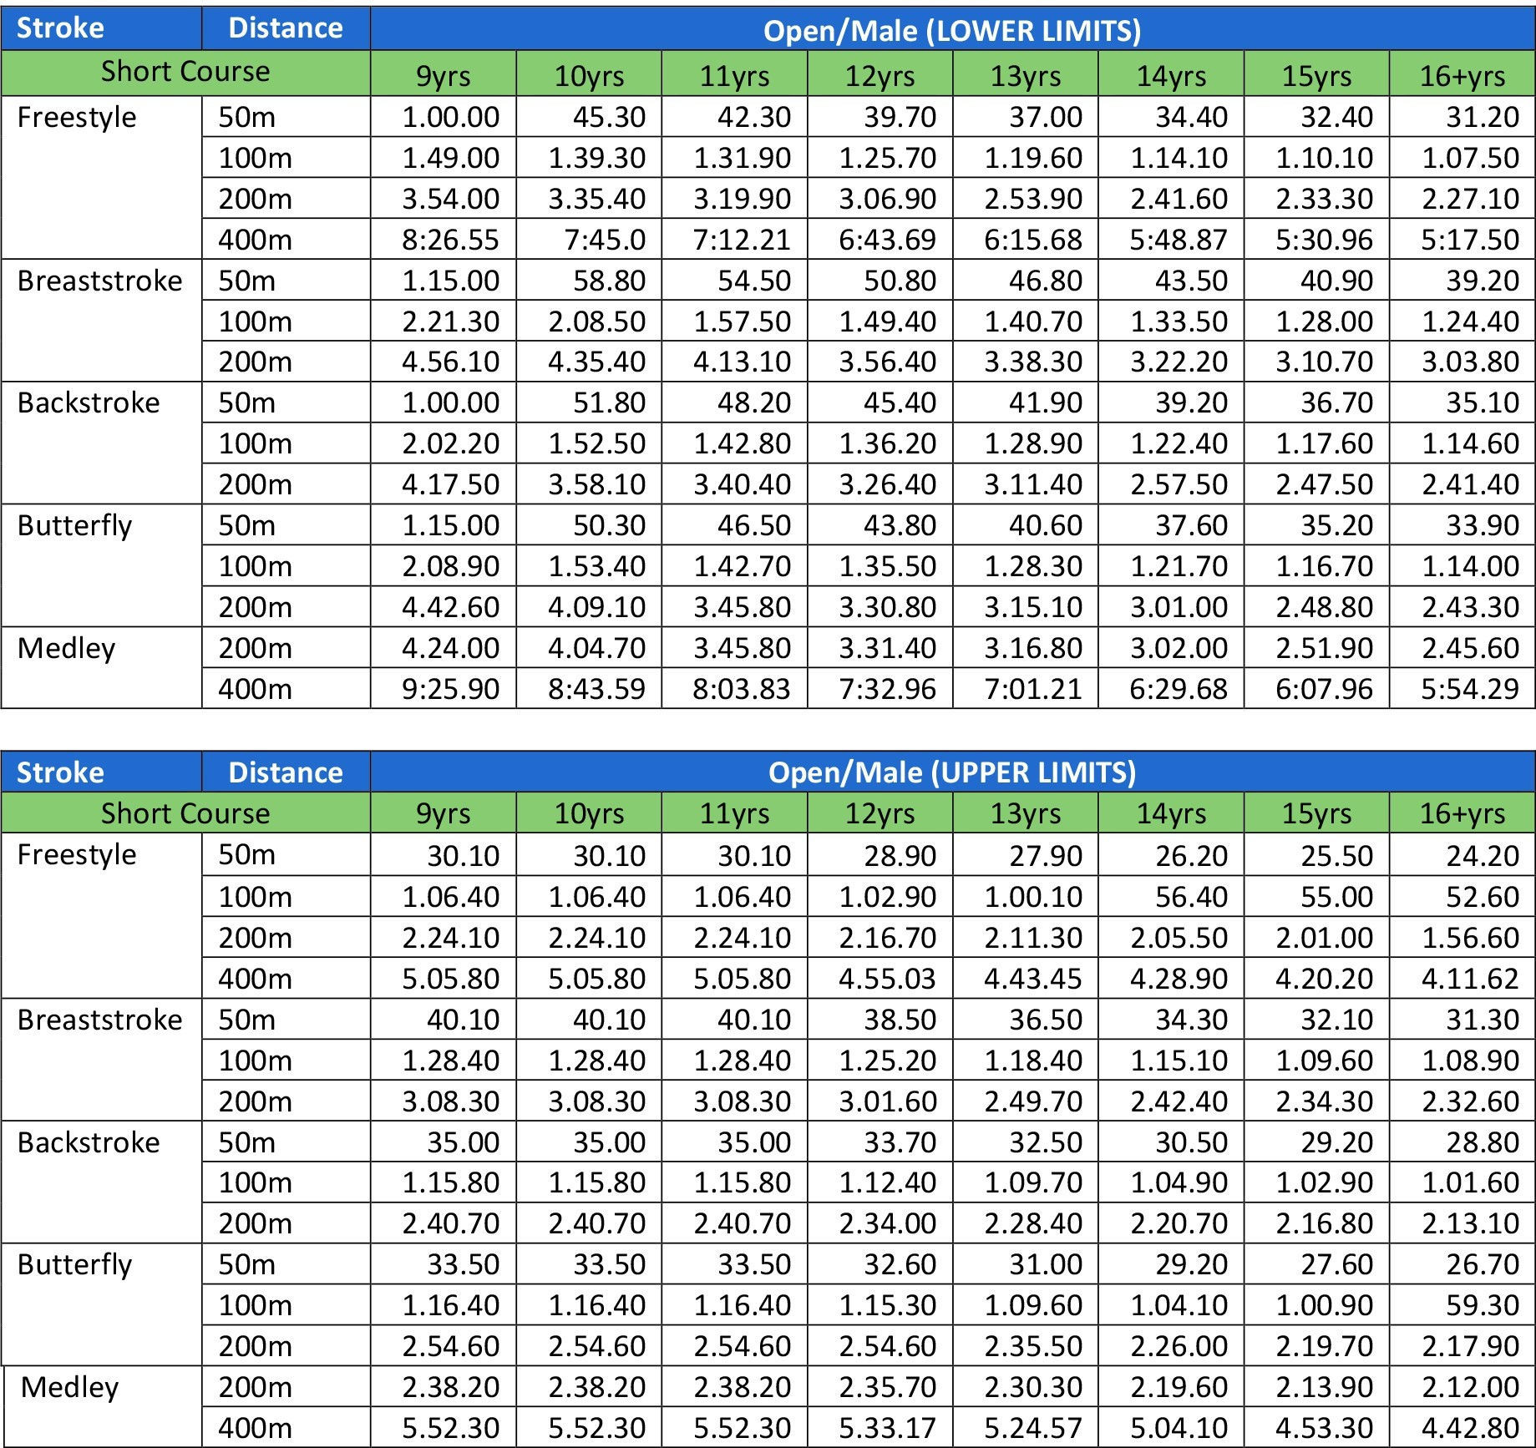

No Time Entries will be considered after all other entries have been processed.

